4 fdisk -l

Record a screenshot

8 Select /dev/sdc from the drop-down menu  
8.a Select Device -> Partition Table; confirm.  
8.b Select Partition > New from the menu  
8.c New Size = 10240  
8.d Create as = Primary Partition  
8.e File system = ntfs  
8.f Click Add  
8.g Partition -> New from the menu to create another partition  
8.h Create as Primary Partition  
8.i New Size: don’t change  
8.j File System: ext4  
8.k Click Add  
8.l Click the Green check to commit  
Open gparted again and Record screenshots of both virtual drives in gparted

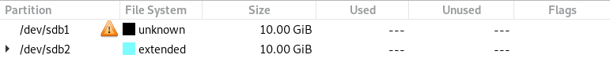

3 lsblk -f  
Record a screenshot

Record the change with

4 lsblk -f > ~/blockdevsMMDDYY

